Dice War in C

**1 Design and Implementation**

Modular Programming is implemented to achieve this goal. The requirement was to achieve thread synchronization which is achieved by thread semaphore and mutex variables which locks and unlocks the resources when needed in main program 5 threads are created 4 for players and one for dealer to automize the random number generator for dice throw.

Dice throw function throws two dices which are randomized with a seed value which was given as a command line argument from user.

**2 Results**

These are some sample results with different seed values. Seed value defines the range and scale of randomize number which can be choosen.

With seed value 30.

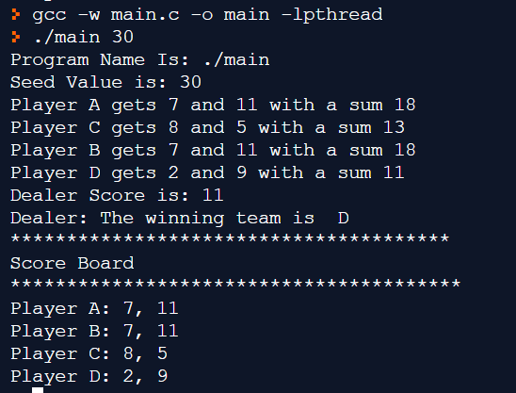

With seed value 19

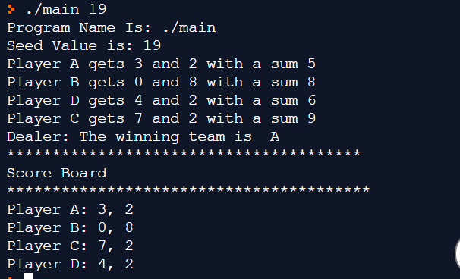

With seed value 20

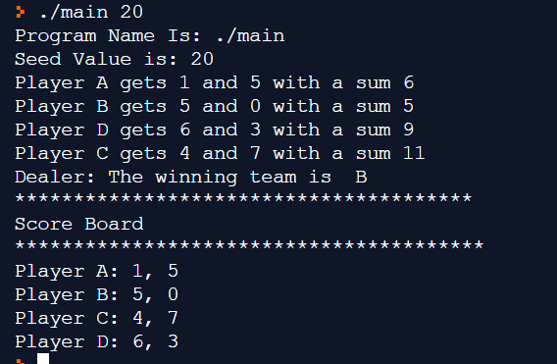

With seed value 15

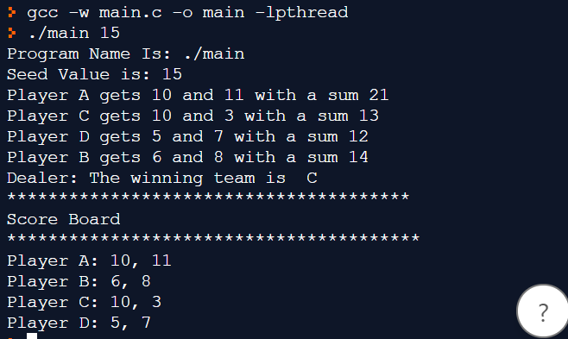

With seed value 10

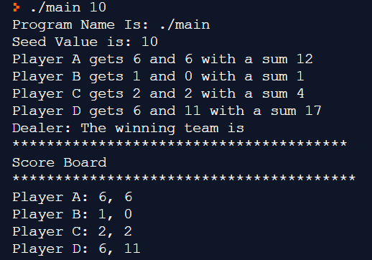

**3. Instructions**

A single code file is compiled to run the code the following command will compile it in ubuntu environment because windows could not support pthread library without changing the cmake file

**Gcc –w main.c -o main -lpthread**